**Phocas React Testing Exercise Stub**

*This project contains a preconfigured react app connected to the graphql endpoint.*

*It is written in typescript if you would prefer to use JavaScript is easy enough to change the tsx / ts extensions to jsx / js and remove the type information from the files.*

*The sample query does perform a query against an organisation. Using insomnia workspace you will want to create an organisation for your exercise.*

**Solution**

*The solution is made available on following link:*

[**https://phocas-coding-exercise.netlify.app/**](https://phocas-coding-exercise.netlify.app/)

*The steps followed to achieve the result are explained below:*

* **Step 1: Following Graphql mutation is executed to create a new organization, using Insomnia Workspace.**

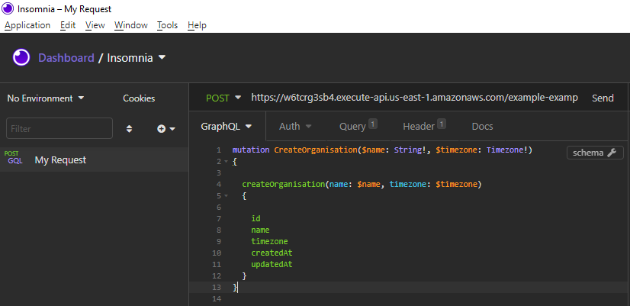

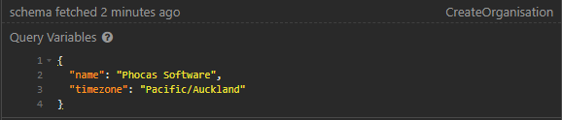

*Result from mutation query is recorded as follows:*

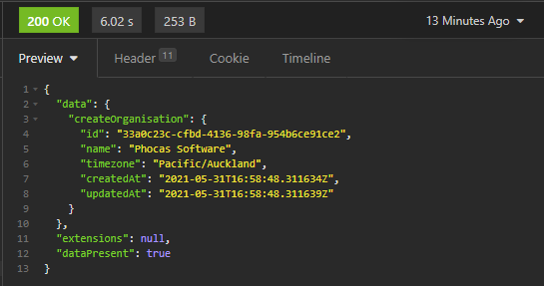

* **Step 2: To confirm that organization is successfully created in the database, query against an organization is executed by passing organization id as argument.**

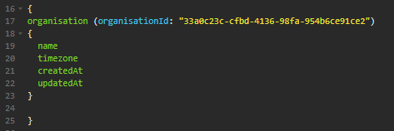

*Result from Organisation query is recorded as follows:*

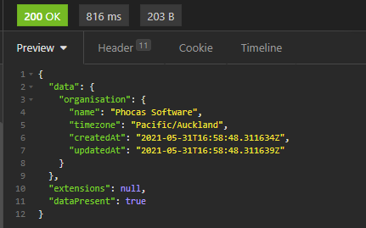

* **Step 3: A new query “organization” is created in the react App at following path:**

**Phocas-react-stub-master/src/queries/organization.ts**

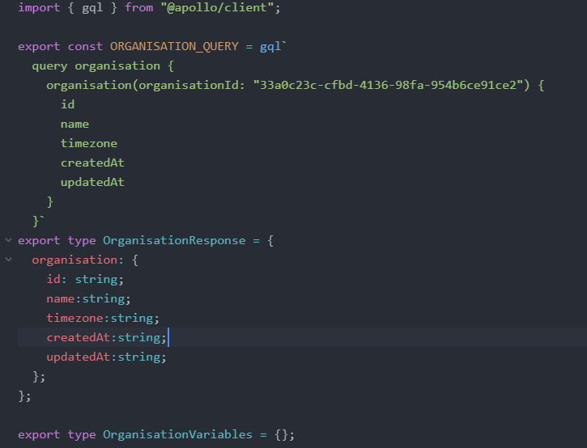

* **Step 4: A new component “organization” is created in the react App at following path:**

**Phocas-react-stub-master/src/components/organization.tsx**

*This component displays organization information on the page.*